# Exercises: Simple Commands

Test your solutions in the **judge system**: [https://judge.softuni.org/Contests/4624](https://judge.softuni.org/Contests/4624/Simple-Commands-and-Visual-Studio-Exercise)

## Text Reading

Write a **console program** that:

* Reads **input** from the console
* Print the **entered** text on the console

string input = Console.ReadLine();

Console.WriteLine(input);

### Example

|  |  |
| --- | --- |
| **Input** | **Output** |
| C# Rocks | C# Rocks |

## Square Area

Write a **console program** that:

* Reads the integer number, which represents the **length of one side of a square**
* Calculates **its area**
* Prints the **calculated area** on the console

**Note**: Square's area is calculated when you multiplied length by length: **length * length**

**int sideA = int.Parse(Console.ReadLine());**

Console.WriteLine(sideA * sideA);

### Example

|  |  |
| --- | --- |
| **Input** | **Output** |
| 2 | 4 |
| 6 | 36 |

### Instructions

1. **Initialize** an int variable (a) and **assign a value** from the **input from the console**



1. Initialize a second variable named **area,** in which you will **store the value for the square’s area**, obtained using **the formula a * a. Print the resulting value.**

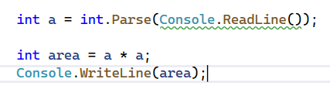

## Rectangle Area

Write a **console program** that:

* Reads two integer numbers, which represent the **length and width of the rectangle**
* Calculate the **rectangle's area**
* Prints the **calculated area** on the console

**Note**: The Rectangle's area is calculated when you multiplied length by width: **length * width**

int lenght=int.Parse(Console.ReadLine());

int width = int.Parse(Console.ReadLine());

int rect = lenght * width;

Console.WriteLine(rect);

### Example

|  |  |
| --- | --- |
| **Input** | **Output** |
| 2  5 | 10 |

## Trapezoid Area

Write a **console program** that:

* Reads three integer numbers, which represent the **first** **base, second base and height of the trapezoid**
* Calculates **trapezoid's area**
* Prints the **calculated area** on the console

**Note**: The Trapezoid's area is calculated when you sum two bases, divide them by two and the result is multiplied by height: **(first base + second base) / 2 * height**

**int firstB=int.Parse(Console.ReadLine());**

int secB=int.Parse(Console.ReadLine());

int height=int.Parse(Console.ReadLine());

int trap = (firstB + secB) / 2 * height;

Console.WriteLine(trap);

### Example

|  |  |
| --- | --- |
| **Input** | **Output** |
| 6  2  3 | 12 |

## Triangle Perimeter

Write a **console program** that:

* Reads three integer numbers, which represent **sides of the triangle**
* Calculates the **triangle's perimeter**
* Prints the **calculated perimeter** on the console

**Note**: The Triangle's perimeter is calculated when you sum all sides values.

int one=int.Parse(Console.ReadLine());

int two=int.Parse(Console.ReadLine());

int tree=int.Parse(Console.ReadLine());

int perimeter=one+two+tree;

Console.WriteLine(perimeter);

### Example

|  |  |
| --- | --- |
| **Input** | **Output** |
| 6  2  3 | 11 |

## Inches to Centimeters Converter

Write a console program:

* Reads **a length in inches** from the console
* Converts it to **centimeters**
* Print the **converted length in centimeters on the console**

**Note: For calculation, multiply the inches by 2.54** (1 inch = 2.54 centimeters).

int inch=int.Parse(Console.ReadLine());

double cm=2.54;

double inchToCm=(double)(inch * cm);

Console.WriteLine(inchToCm);

### Example

|  |  |
| --- | --- |
| **Input** | **Output** |
| 5 | 12.7 |
| 7 | 17.78 |

**Attention**: depending on the **regional settings** of the operating system, instead of a **decimal point** (US settings), a **decimal comma** (BG settings) may be used by default. If the program expects a decimal point and a number with a decimal comma is entered, or vice versa (a decimal point is entered when a decimal comma is expected), the following error will occur:  
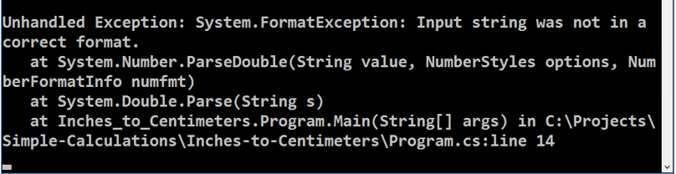

It is recommended to **adjust your computer settings to use a decimal point**:

